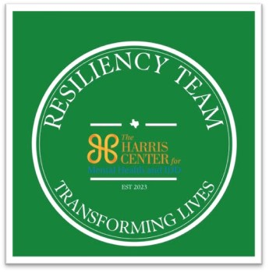
Crisis Response Informational Form
Date Response needed
Response Information:
Organization/Agency Name:
Contact Person Name:
Contact Person Title/Role:
Contact Person Phone:
Contact Person Email:
Incident Information:
Date and Time of Incident:
Location of Incident: Description of Incident:

What has been done already for affected individuals since the incident occurred?

What has been the response/reaction of those immediately affected?

Has the media reported about the incident or anything else that would be helpful for the team to know before responding?

Affected Individuals: (Please provide information about the individuals affected by the incident that would help our team when responding):

Response:

Material that The Harris Center Crisis Team will bring: Will bring brochures for The Harris Center,

What location or locations would you like to have support from the team? What is the maximum number of individuals you think could come needing help?

What ages are the individuals affected (this helps us determine the number of groups needed and number of staff to send)?

